Advanced study.

Simulators are made in order to test and demonstrate hypothesis faster. One of the ways of finding the optimal solution is by tuning parameters, trying to reach a valid result by changing the conditions of the object. In this case the geometry of the object is mainly defined by its expansion angle.

For this advanced study it has been decided to represent the evolution of the downstream magnitudes for every value of the corner angle, starting at -10º until reaching 0º. This allows us to easily see the evolution and impact of changing the angle in the simulation results.

In order to do that, it will be found the solution for every angle between -10º to 0º with a 0.1º and then plot the magnitudes together using the “Livecharts.WPF” library. The result is the following:

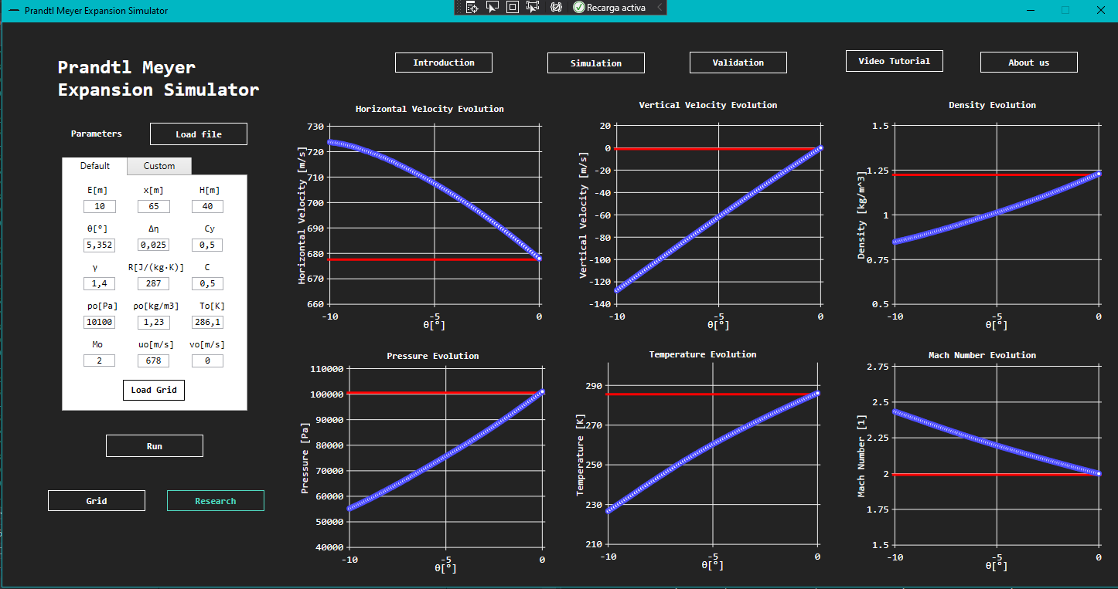

With these plots we can actually understand what is the behaviour of the fluid if we have gone from one angle to the other. Complementary to this, and in order to check the results, the horizontal red lines have been added which correspond to the initial values of the fluid properties. As it can be seen for $0º$ of deflection the values downstream are the same as upstream (initial), this makes sense because there is no perturbation on the fluid and the magnitudes of the fluid are kept along the experiment area.

Concluding with the advanced study, increasing the angle of the expansion corner generates a higher perturbance on the fluid and therefore the change of the variables is more notable, it can be affirmed that the effects of the Prandtl Meyer expansion are directly proportional with the increasing speed and Mach number and decreasing of density, temperature and pressure.